Steps to program attiny85 using Arduino
Step 1: Connect Arduino uno and upload ArduinoISP code from File > Example > ArduinoISP, make sure attiny is not connected.
Step 2: Add the attiny board manager from settings if plugged in for first time. Paste the code “https://raw.githubusercontent.com/damellis/attiny/ide-1.6.x-boards-manager/package_damellis_attiny_index.json”
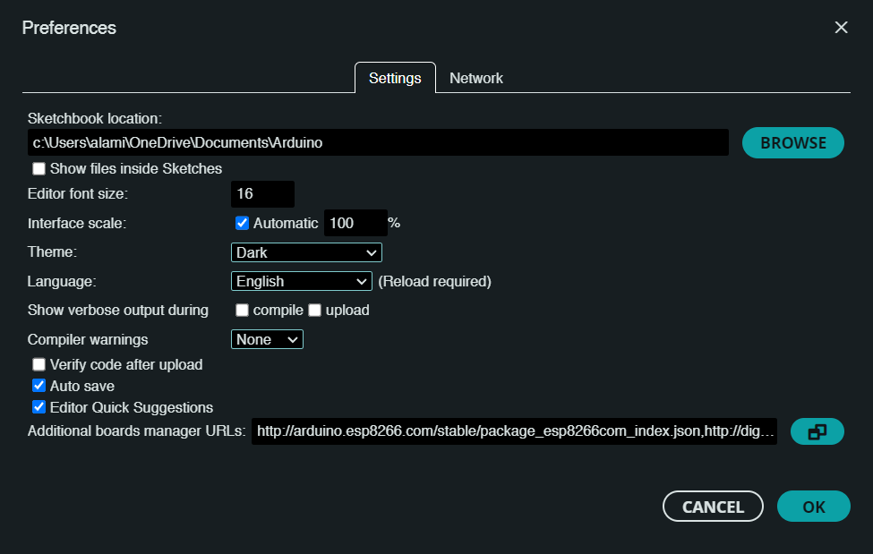
Step3: Select board from tools:
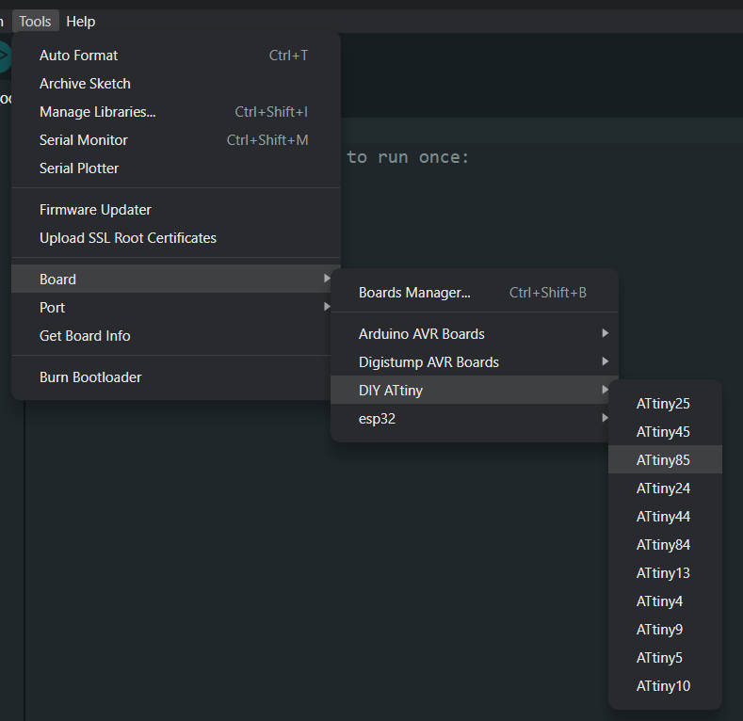
Step 4: Check the parameters of the chip.
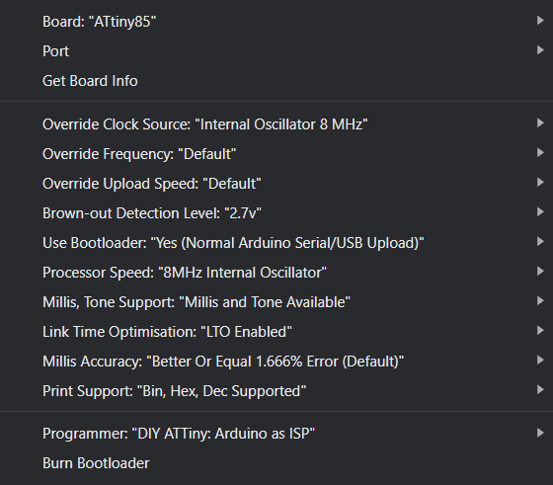
Step 5: Connect the chip to Arduino as shown:
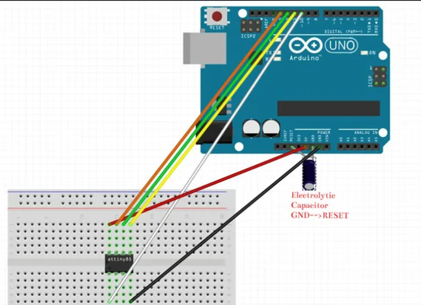
Step 6: Connect a 10uF or 20uF capacitor on Arduino pin GNDReset (Important), set arduino as ISP
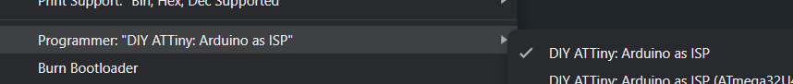
Step 7: Burn the bootloader. A burn bootloader is necessary if the code does not upload to Arduino and shows a synchronous error.
Step8: Write any code and upload using programmer.
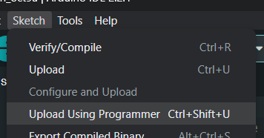

Voltage range of attiny85: 2.7 to 5.5V
Program storage: 8Kb
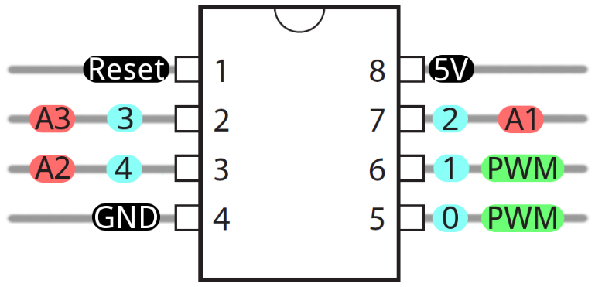
Connection:
Pin 1 ------> RST(P5) ------> 10(ard, SS {SPI})
Pin 4 ------> GND ------> GND(ard)
Pin 5 ------> P0 ------> 11(ard, MOSI {SPI})
Pin 6 ------> P1 ------> 12(ard, MISO {SPI})
Pin 7 ------> P2 ------> 13(ard, SCK {SPI})
Pin 8 ------> VCC ------> 5V(ard)

